MTCS – 103(P) Parallel Processing

Labwork 5&6 Report
by
Sai Suraj - 21560

I have developed a parallel code for Matrix Multiplication of size N where
rows of A are multiplied to columns of B. I have used a Global variables for Size
N, Matrix A, B, and Resulting Matrix C. I am reading the text files from input files format matA_N and matB_N where N is the order of matrix.

I have checked for correctness of my program and executed the code for
matrices of int of size N= 500, 1000,1500, 2000,2500,3000,4000 and tabulated
the execution time taken in each case.Number of threads used were 8.I have taken average for 3 number of runs. Plotted the change in the total execution time to compare.
Order of Matrix (N) | Execution Time in Seconds
500 | 0.146571
1000 | 2.31561
1500 | 10.4999
2000 | 32.39123
2500 | 70.93284
3000 | 157.69587
4000 | 296.12354
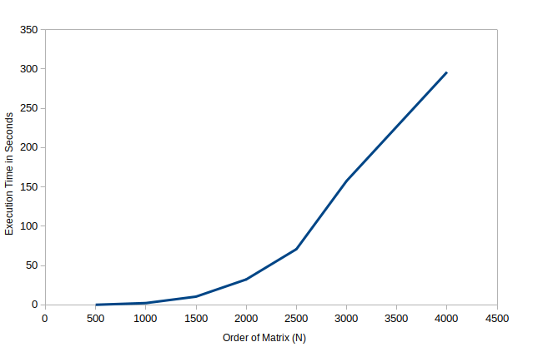

For Smaller Matrix size, The Execution time remains constant at 0. And, As Matrix size increases, execution time increases.And When the Execution time is compared with Sequential results, The execution time for smaller size matrix is less and the execution time for larger size matrix is very less. For Larger Matrix Size, It gives twice the performance of the sequential results.
Since I am using Intel(R) Core(TM) i7-8550U CPU @ 1.80GHz with 4 VCPU’s , It takes less time to compute as i am able to use 8 threads for computation.

